**Department of Computer Science and Engineering**

**Sub: iOS application development using swift**

**Assignment No 1**

**Name :** Suraj Shantinath Upadhye. **PRN :** 245200001  **Class :** SY CSE

1. 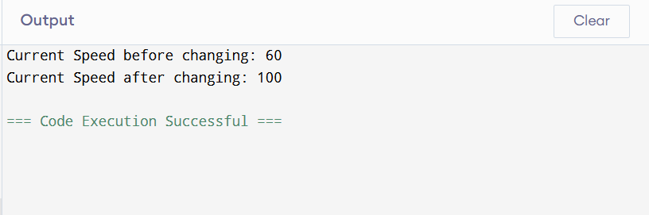Declare a constant named maxSpeed with a value of 120 and a variable currentSpeed with an initial value of 60. Then, modify the value of currentSpeed to 100. What will happen if you try to modify maxSpeed after it's initialized?

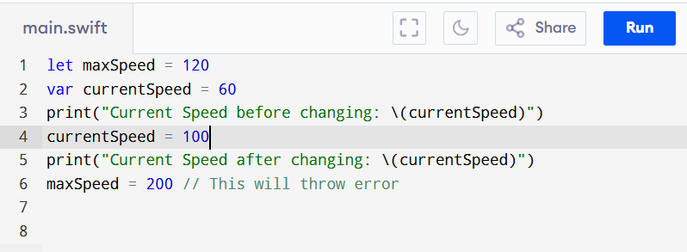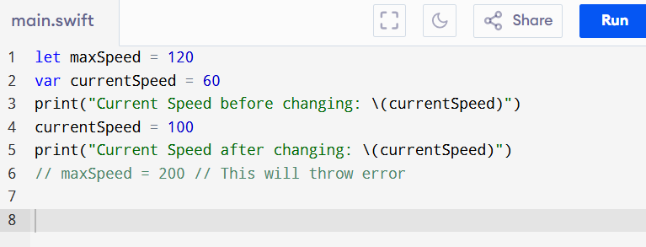

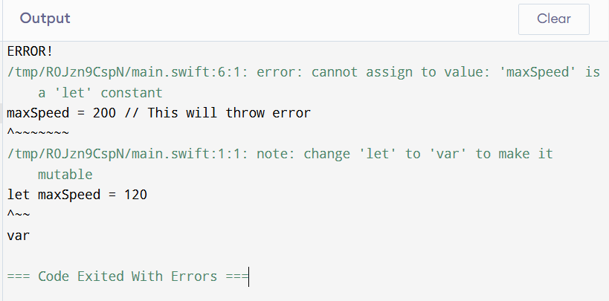

If we modify the maxSpeed i.e. constant will throw error message because we cannot change the value of constants. The constants are immutable in nature.

1. 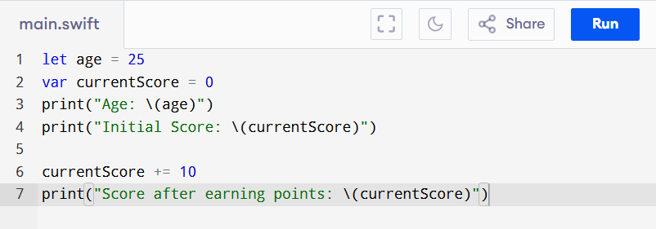Write code where a constant stores the value of a person's age and a variable stores their current score in a game. Demonstrate why one needs to be a constant and the other a variable.

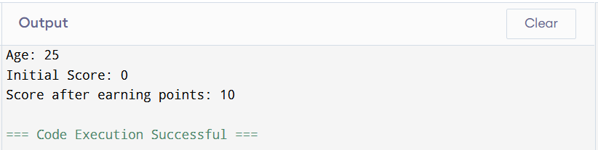

Here we used constant for age because age not changes suddenly so we have taken it as constant and currentScore as variable because score can change in the game as we progress it may increase or decrease.

1. 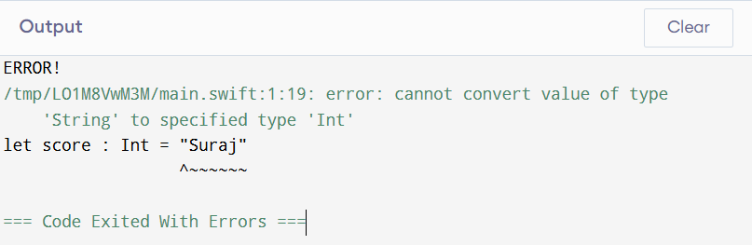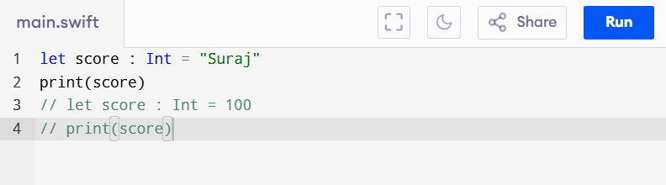Declare a constant score of type Int and attempt to assign a String value to it. What happens? Fix the error.

So here we have created a constant score using let of type Int and assigned a String value which is “Suraj” but it will throw error message as we cannot assign the String value to Int variable because it cannot convert the value of type String to specified type ‘Int’.

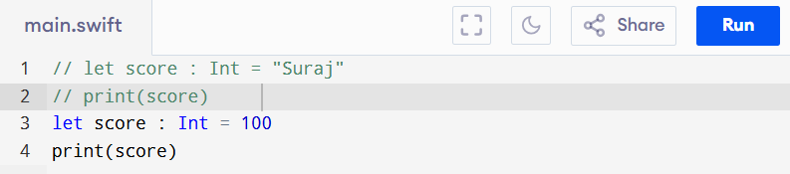

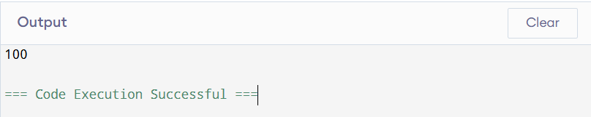

To fix this error we need to assign the appropriate Integer value to that Int variable or constant whatever it is.

1. Declare a variable greeting and initialize it with the string "Hello, world!". What type will Swift infer for this variable? Print the type using type(of:).

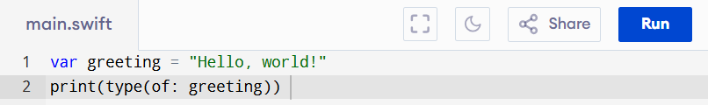

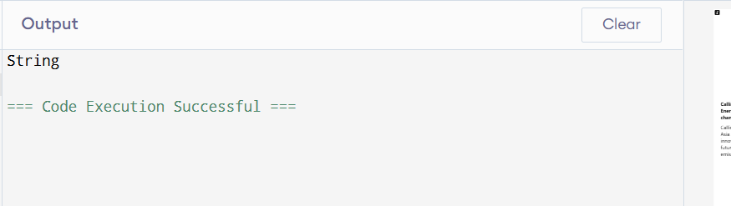

1. 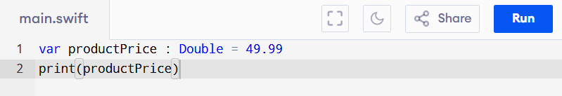Declare a variable productPrice with type annotation Double and initialize it with the value 49.99.

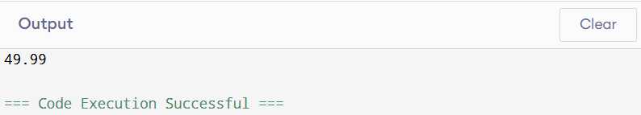

1. Write a program that uses a switch statement to print the day of the week. Given a number between 1 and 7, print:

1: "Monday"

2: "Tuesday"

3: "Wednesday"

4: "Thursday"

5: "Friday"

6: "Saturday"

7: "Sunday"

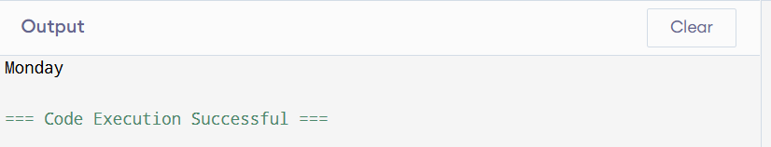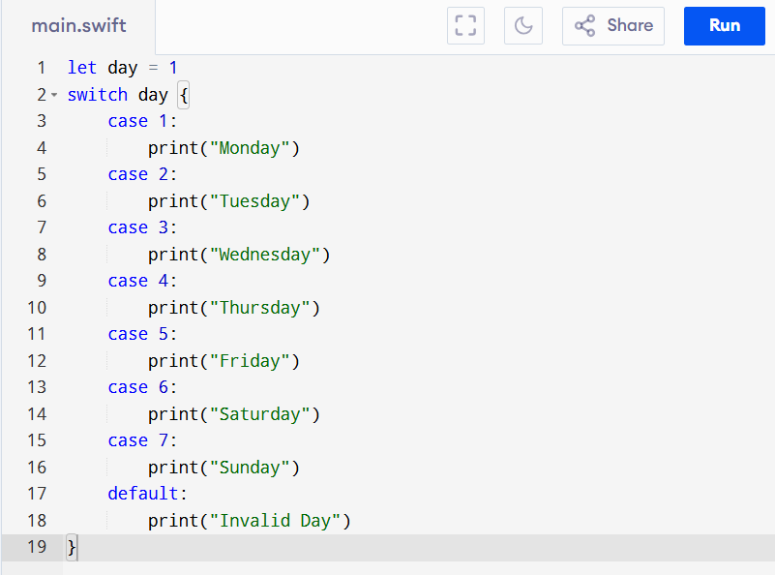

1. Write a program that takes an age as input and prints the category the person falls into using a switch statement:

0–12: "Child"

13–19: "Teenager"

20–64: "Adult"

65 and above: "Senior"

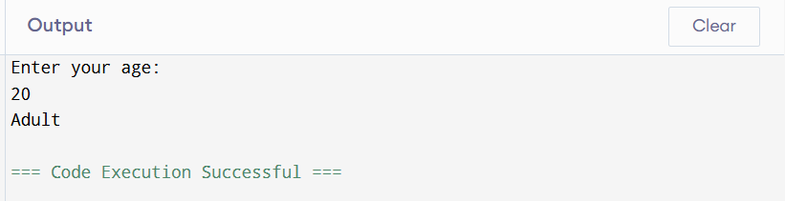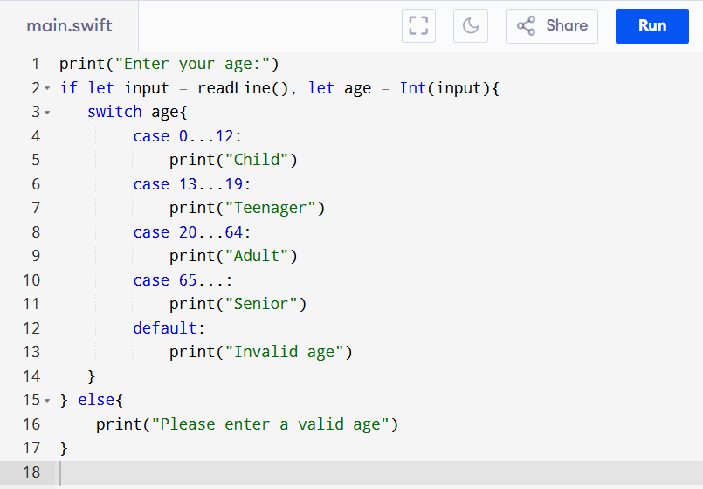

1. Write a program that checks the current temperature. If the temperature is below 0°C, print "Freezing". If it's between 0°C and 20°C, print "Cold". If it's above 20°C, print "Warm".

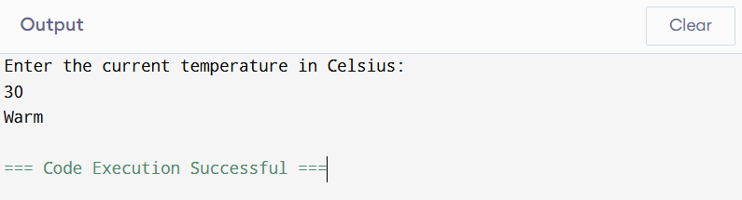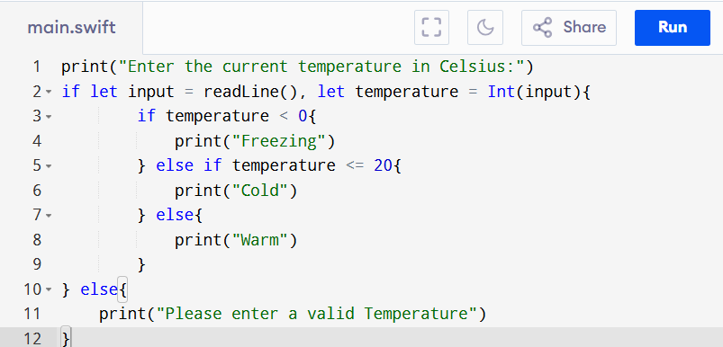

1. Write a program that checks if a person is eligible for a loan. The person is eligible if:

* They are at least 21 years old.
* They have a credit score of 700 or higher.
* If both conditions are true, print "Eligible for loan", otherwise print "Not eligible for loan".

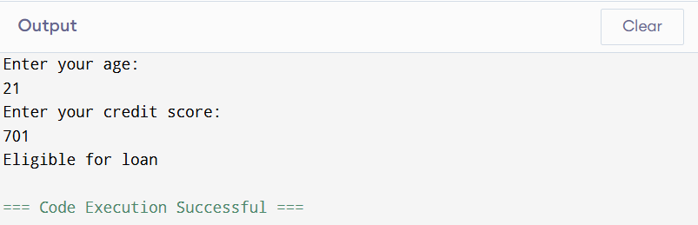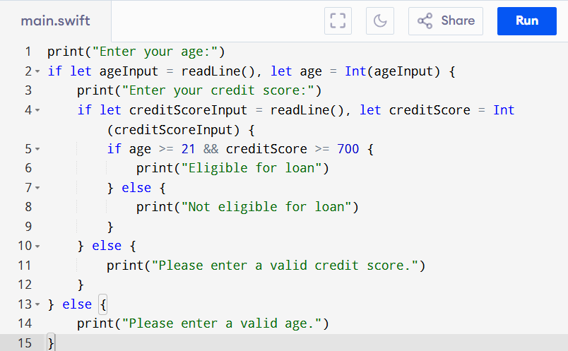

1. Write a program that uses a switch statement to determine the grade based on the score:

* 90–100: "A"
* 80–89: "B"
* 70–79: "C"
* 60–69: "D"
* 0–59: "F"

Ensure the switch statement covers all possible cases.

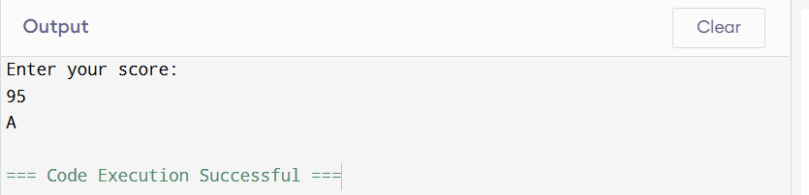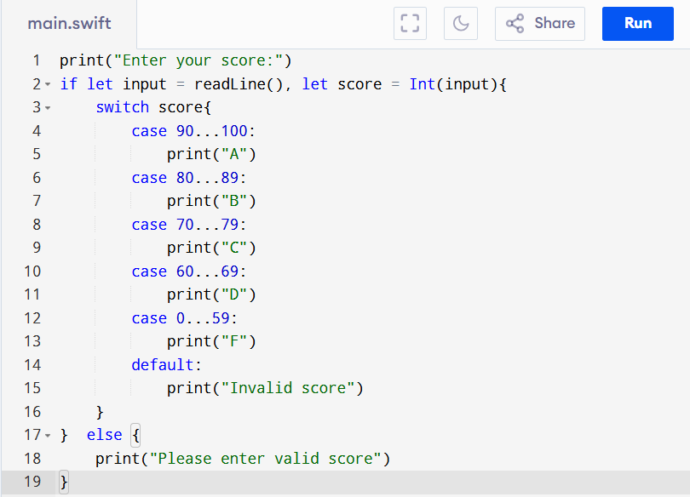

1. Write a program that checks if the entered password is correct. Declare a Boolean variable isPasswordCorrect:

* If the value of isPasswordCorrect is true, print "Access granted".
* If the value is false, print "Access denied".

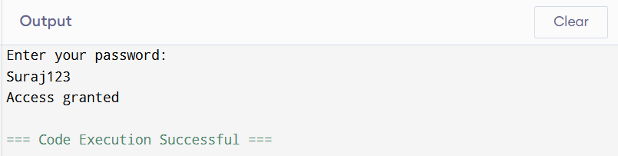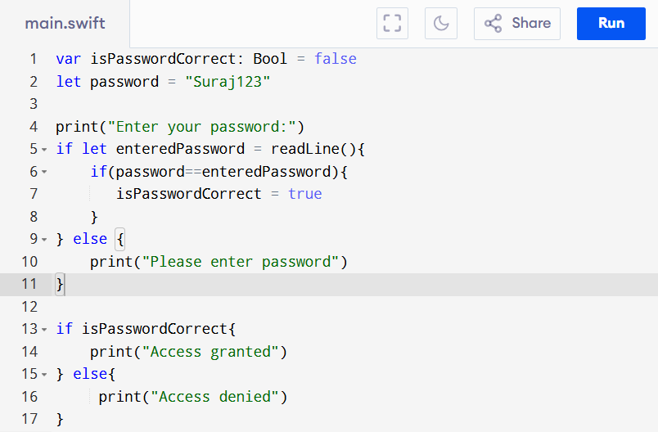

1. Write a program that suggests an activity based on whether it's a weekend and if it's raining:

* Use isWeekend and isRaining as boolean variables.
* If it's a weekend and it's not raining, print "Go hiking".
* If it's a weekend and it's raining, print "Watch a movie".
* If it's a weekday, print "Go to work".

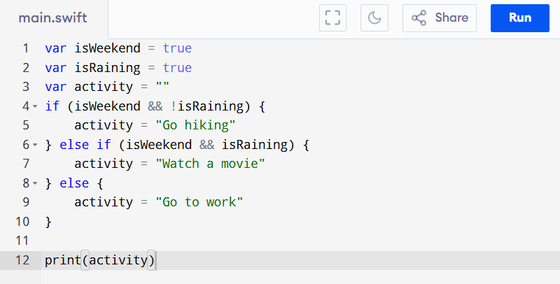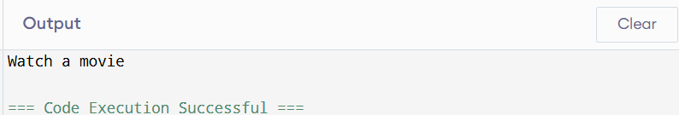

1. Write a program that uses the ternary operator to evaluate a student's grade:

* If the grade is 60 or higher, print "Passed". Otherwise, print "Failed".
* 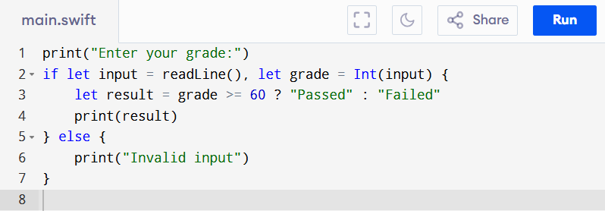Use the ternary operator to check the grade and assign the result to a variable.

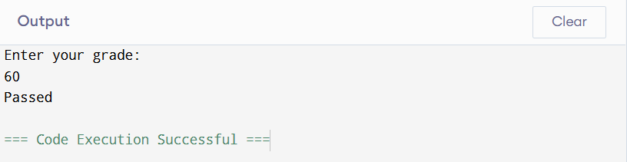

1. Declare a name constant and assign your name as a string literal with proper capitalization. Then declare an age constant and give it your current age as an Int.

Write an if-else statement that checks to see if name is in capitals, If yes Then print the following phrase using string interpolation: My name is and after my next birthday I will be years old. Insert name where indicated, and insert a mathematical expression that evaluates to your current age plus one where indicated.

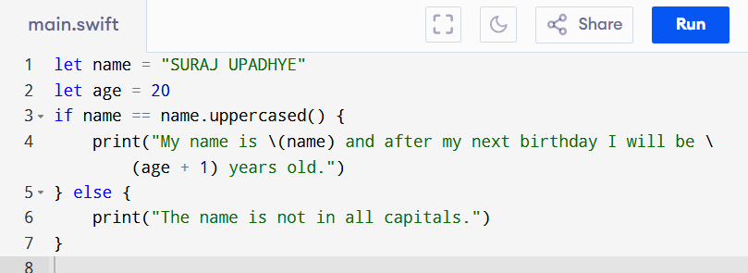

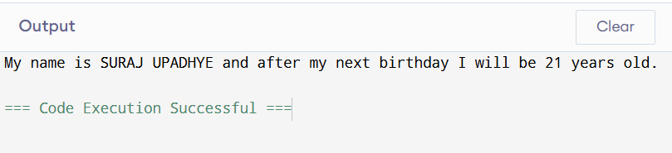

1. Imagine you are looking through a list of names to find any that end in Jr; Write an if statement below that will check if “junior” has the suffix;Jr If it does, print We found a second generation name;

let junior =Cal Ripken Jr;



